## <COVER PAGE>

<Text box in upper left corner>

**Phase 2 Draft: Released May 1, 2025**

**Industry comment period ends: May 30, 2025**

**Submit comments to** [**regionalplans@visitcalifornia.com**](mailto:regionalplans@visitcalifornia.com)

<IMAGE> <https://assets.visitcalifornia.com/media/?viewType=grid&mediaId=ECCF16C4-F25F-4DC2-BCB37D6B994F546D>



## Resilience and sustainability scorecard

# **Central Coast**

May 2025

## <INSIDE COVER>

<Text box on left side of page>

The development of these regional scorecards was funded by a State Tourism Grant awarded to Visit California as part of the U.S. Economic Development Administration’s Travel, Tourism and Outdoor Recreation program. The program invested federal funds appropriated by the American Rescue Plan Act to support states and communities whose tourism economy was damaged by the COVID-19 pandemic.

The majority of the grant funds were used to directly support tourism recovery through marketing initiatives. With the EDA’s oversight, a portion of the grant was directed to the development of these scorecards, which are designed to build a more resilient travel and tourism sector in California.

Visit California extends its gratitude to the diverse project teams, strategic partners and industry experts whose contributions were instrumental throughout the two-year process.

<Project partner logos>

<PAGE IMAGE> <https://assets.visitcalifornia.com/media/?mediaId=A26E98B2-5C49-4A7B-B32D32CE08E8F118>



<Image text box in lower left corner> Pebble Beach Golf Links

## Executive summary

The Central Coast region offers a wealth of experiences from hiking along the rugged coastline of Big Sur to exploring the historic streets of Santa Barbara and sipping wine in Santa Ynez Valley. Much of what attracts tourists to the region stems from the spectacular natural environment of the Central Coast. Yet, this treasured landscape faces growing risks, as climate change and related natural disasters increasingly threaten tourism across California, including the Central Coast.

The region faces three primary concerns that could undermine its tourism resilience and long-term sustainability.

Top Risks

1. Limited disaster response infrastructure  
   The Central Coast lacks critical emergency infrastructure, hindering its ability to respond to and recover from disasters.
2. Escalating climate and hazard risks  
   Rising heatwaves, droughts, and earthquake exposure — especially in vulnerable sub-regions — pose growing threats to the tourism sector.
3. Hidden community vulnerabilities  
   County-level data masks challenges faced by priority populations in places like Gilroy, Watsonville and Salinas, limiting equitable resilience planning.

The most critical issue is the region’s lack of essential infrastructure for disaster preparedness and response. This gap includes insufficient emergency shelters, hospitals and other vital systems needed to effectively manage disasters. Without these support structures, the region remains highly vulnerable during crises, with limited capacity for swift response and recovery, posing serious risks to both residents and visitors.

While the region scored well in understanding risks, the data shows exposure to climate-related and natural hazards. Heatwaves are intensifying in San Luis Obispo, Santa Barbara and Ventura counties, drought is a rising concern in Monterey and Ventura and earthquake risk is notably high in northern inland areas such as Gilroy and Hollister.

The region shows gaps in addressing social vulnerability and community resilience, particularly in underserved communities. Although community well-being scored as “good” overall, the assessment relies on county-level data, which may obscure challenges faced by priority populations in places like Gilroy, Watsonville and Salinas. This limits the ability to identify and support the most at-risk communities, undermining equitable resilience and the role tourism could play in supporting broader community well-being.

To help tourism stakeholders prepare for, respond to and recover from a changing climate and other risks, the resilience and sustainability scorecard explores metrics across seven critical success factors (CSFs) to identify and define the challenges facing the region. The scorecard blends spatial data layers and quantitative analysis with qualitative input from regional experts in a panel format. Panelists were selected to reflect diverse perspectives across tourism, land and water management, environmental sustainability, government, Indigenous leadership, infrastructure and regional planning.

The resulting quantitative and qualitative ratings provide a baseline risk assessment from which opportunities are identified to improve the region’s sustainability and resiliency to identified risks. For more background on the methodology, see Scorecard Overview.

The Central Coast Resilience and Sustainability Scorecard is a summary of results of this extensive process, with each dial chart representing the overall quantitative rating for each CSF. 40 different indicators in total were selected across the seven CSFs. The various units of measurement for the CSF indicators were normalized to a ratings scale of 0 to 100 to simplify comparisons and develop composite scores by CSF. The scores were then divided into five equal tiers — low, fair, good, very good and exceptional — where the higher the score, the better the CSF overall performance.

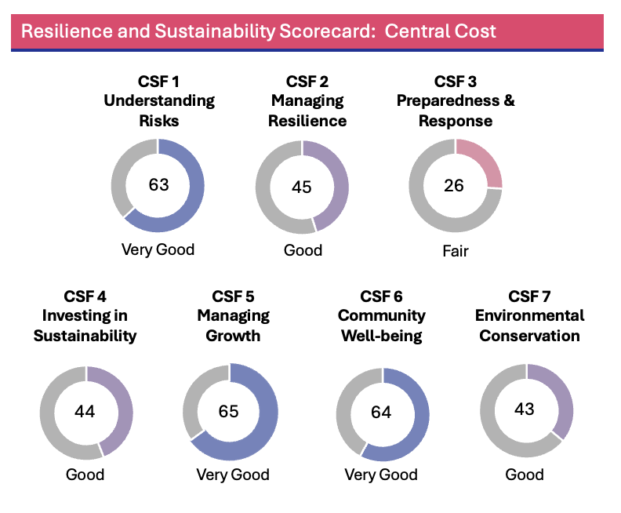

## Interpreting the scorecard

### CSF 1 Understanding risks — Very good

At the regional level, tourism businesses are expected to experience limited losses over time from various hazards. However, sub-regions do face higher exposure to specific risks and should plan accordingly. San Luis Obispo, Santa Barbara and Ventura counties are especially vulnerable to intensifying heatwaves. Droughts will be increasingly challenging for Monterey and Ventura counties. Pockets near Gilroy and Hollister, Paso Robles, Santa Barbara and Ojai stand out as having heightened earthquake risk.

### CSF 2 Managing resilience — Good

While several cities and counties in the region have established strong resilience plans, like Santa Barbara County’s 2030 Climate Action Plan, opportunities for improvement remain. Some destinations have begun to address tourism-related risks in their planning efforts. Notable examples include Big Sur Destination Stewardship Plan and Visit SLO Destination Management Strategy, which illustrate how resilience and climate strategies can start to be integrated into tourism planning.

### CSF 3 Preparedness and response — Fair

The region critically lacks essential infrastructure, such as emergency shelters, that are vital in response to and recovery from disasters. The absence of crucial support systems leaves the region vulnerable during disasters and could severely hinder recovery efforts.

### CSF 4 Investing in sustainability — Good

The region’s low greenhouse gas (GHG) emissions per capita have limited competitiveness for and receipt of state funding from the California Climate Investment program, which supports programs to reduce GHG emissions.

### CSF 5 Managing growth — Very good

Overall, the region excels at advancing tourism sustainability without overburdening local infrastructure or communities. However, certain areas, such as Big Sur, experience more concentrated tourism impacts. The Central Coast region shows strength in managing visitor distribution, monitoring tourism impacts, and offering a diverse range of attractions — contributing to a well-balanced and resilient tourism economy.

### CSF 6 Community well-being — Good

Economy-wide, not just tourism, the Central Coast region demonstrates a mixed performance regarding community well-being. Furthermore, key indicators of social vulnerability and community resilience were only available at the county level and may not accurately reflect challenges priority populations face in [disadvantaged communities](https://oehha.ca.gov/calenviroscreen/sb535), such as areas in Gilroy, Watsonville and Salinas (among others).

### CSF 7 Environmental conservation — Good

While the Central Coast region enjoys excellent air quality and a world-renowned coastline, it also contends with water scarcity and limited cultural resources protected through the National Register of Historic Places.

The following sections dive into the findings of the Central Coast regional scorecard and identify opportunities for incremental improvement across the seven critical success factors. While the assessment was carried out at the regional level, the opportunities can be pursued at the local level by tourism businesses and destination management organizations (DMOs) to better understand, prepare for, respond to and recover from the various threats facing the region.

**California Tourism Resilience and Sustainability Dashboard**

All the risk indices and data layers used to develop these indicators are accessible through an interactive dashboard created specifically for California and each of the 12 tourism regions.

**Explore the Central Coast data here:** Central Coast Dashboard

# CSF 1 — Understanding Risks

This CSF focuses on identifying, assessing and communicating the risks that impact the tourism sector.

### CSF 1 key findings

The Central Coast region faces significant exposure to natural hazards, particularly heatwaves, droughts and earthquakes, which present growing risks to tourism infrastructure. Risklayer modeling and FEMA’s National Risk Index identify elevated vulnerability across the region. Projections indicate that heatwave and drought risks will intensify significantly in San Luis Obispo, Santa Barbara and Monterey counties. Earthquake risk, while less frequent, is associated with high potential for economic loss in key tourism zones including Paso Robles, Santa Barbara, Ojai and Gilroy. Annual average loss (AAL) estimates reflect ongoing exposure of tourism assets—including lodging, entertainment, and cultural sites — to climate and geological hazards. These risks are compounded by socioeconomic factors such as low housing affordability, a high homelessness intensity index in some areas and ongoing public safety concerns, particularly in urban centers.

Despite this clear and data-driven risk profile, qualitative feedback from stakeholders reveals a troubling disconnect. Panelists rated the region only 2 out of 5 across all four performance criteria in CSF 1: risk perception, understanding of tourism impacts, risk information sharing, and data-sharing effectiveness. While natural disasters are broadly acknowledged as a concern, stakeholder awareness of economic, environmental, public health and technological risks remains limited. Climate change impacts, such as intensifying drought and heat, are underappreciated relative to their modeled severity.

Risk information is inconsistently available, with current systems characterized by fragmented communication and only partially effective data sharing. Improvement strategies for CSF 1 should aim to bridge this gap by enhancing risk awareness, improving data sharing mechanisms and fostering better communication between tourism stakeholders and emergency planning entities. These efforts can help build a more informed and prepared tourism sector, strengthen coordination during emergencies and support proactive decision-making to reduce vulnerability and protect both visitors and tourism assets.

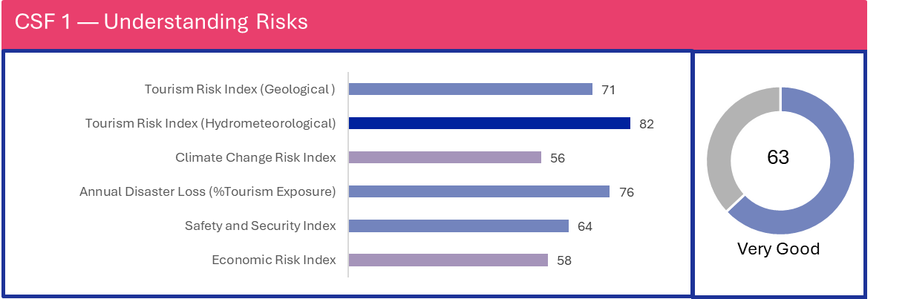

### CSF 1 quantitative ratings and findings

CSF 1 assesses various geological risks including earthquakes, landslides and tsunamis, as well as hydrometeorological and other hazards such as floods, windstorms, heatwaves, hail and wildfires, evaluating their impact on the region's tourism exposure data.

To assess tourism exposure for loss calculations (**AAL - Average Annual Loss**), the RES4, COM8 and COM9 occupancy classes from [FEMA’s Hazus National Building Inventory](https://www.fema.gov/sites/default/files/documents/fema_hazus-inventory-national-database-dictionary.pdf)[1] were chosen; **AAL represents the estimated financial loss a location can expect to incur each year from disasters, averaged over time based on hazard frequency and severity.**

These FEMA classes collectively represent the accommodations, entertainment and cultural attractions that define tourism infrastructure:

* RES4 (temporary lodging) includes hotels, motels and resorts where tourists stay.
* COM8 (entertainment & recreation) encompasses amusement parks, casinos, stadiums, golf courses and other leisure venues.
* COM9 (theaters & cultural facilities) covers museums, performing arts centers and historic attractions.

CSF 1 assesses the understanding of risks to tourism using the following quantitative metrics:

#### Tourism risk index (geological and hydrometeorological)

Incorporates Risklayer modeling of average annual losses (AAL) from exposed accommodations and tourism attractions. The Federal Emergency Management Agency (FEMA) [National Risk Index](https://hazards.fema.gov/nri/), which compiles data from various sources, provides the hazard models.

The geological index evaluates risks from earthquakes, landslides, volcanoes and tsunamis, all linked to geological processes. The hydrometeorological tourism risk index assesses natural hazards associated with atmospheric processes, including floods, hurricanes and wildfires. All hazards were analyzed and integrated into the index score, allowing identification and highlighting of the highest risks in the findings.

#### Climate change risk index

Assesses the severity of climate-related events, such as heatwaves, droughts, snowfall and increased precipitation, on tourism assets and local communities. Each climate indicator is calculated using different metrics, like mean annual precipitation, extreme maximum temperature and precipitation as snow, for different CMIP6 climate scenarios (ssp245, ssp370, ssp585) and projected years (2030, 2050, 2070, 2090) provided from [AdaptWest](https://adaptwest.databasin.org/pages/adaptwest-climatena/). The climate change risk index uses a scale from 0 (low risk) to 100 (high risk) to indicate the intensity of these events, highlighting the areas that are most affected by climate variability.

#### Annual disaster loss (% tourism exposure)

Represents the proportion of tourism-related infrastructure exposed to natural disasters and climate impacts, calculated as a percentage of average annual losses. This index helps quantify the economic vulnerability of the tourism sector to recurring disasters. The data originates from FEMA’s [National Risk Index](https://hazards.fema.gov/nri/), a dataset that assesses the relative risk of 18 natural hazards across the United States, combining hazard risk, exposure and social vulnerability data to produce a comprehensive risk score.

#### Safety and security index

Evaluates public safety and security conditions for tourists, considering factors like crime rates, healthcare access and family-friendliness to provide a holistic view of personal security and the overall quality of safety in the region. Additionally, this index incorporates indicators such as COVID-19 vaccination data (specifically the percentage of population with 1+ dose) from [CovidActNow](https://covidactnow.org/?s=50083753) and homelessness data from the U.S. Department of Housing and Urban Development ([HUD](https://www.hudexchange.info/programs/coc/gis-tools/)).

#### Economic risk index

Measures economic stability and risks in areas with significant tourism activity, highlighting economic pressures that could impact the sustainability of the tourism industry. It considers factors like workforce availability (unemployment rate), housing affordability and economic stability. Housing affordability assesses the financial ability of a typical household to purchase an existing home in an area. Economic stability describes the relationship between non-workers and the employed population.

The Central Coast region naturally experiences a Mediterranean climate, characterized by hot, dry summers and mild winters. Its year-round pleasant temperatures have long been a major draw for visitors. However, climate change is projected to increase the frequency and intensity of heatwaves and droughts, posing significant challenges to the area's tourism and agriculture sectors.

During the summer months, extreme heat may deter visitors, particularly in the inland valleys. Regions within San Luis Obispo, Santa Barbara and Ventura counties are especially vulnerable, as they face the most severe impacts of heatwaves and drought. These conditions threaten the region's burgeoning agritourism industry, which relies heavily on attractions like vineyards and olive orchards.

***Figure 1a. Heatwave Risk***

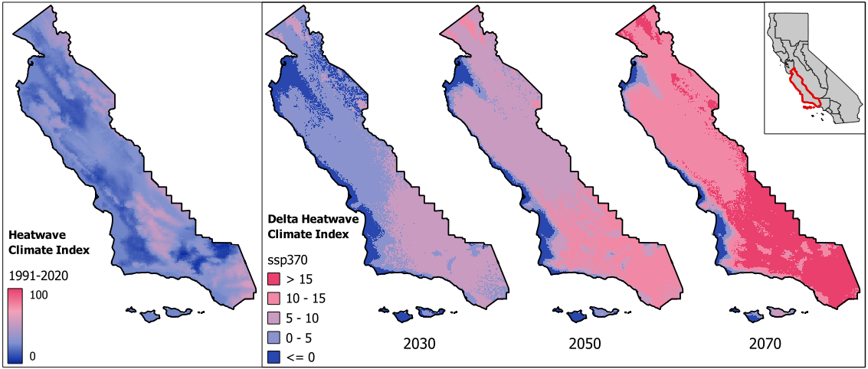

*Source: Risklayer GmbH*

In Figure 1a, the left image illustrates the heatwave climate risk index based on a 30-year historic average between 1991 and 2020, rating the risk from 0 (low) to 100 (high). The right images show increases (score points) in the heatwave risk index from the historic baseline for the years 2030, 2050 and 2070 based on an intermediate emissions scenario, "A Rocky Road" or ssp370 defined in the [Sixth Assessment Report of the Intergovernmental Panel on Climate Change](https://www.ipcc.ch/report/ar6/wg1/downloads/report/IPCC_AR6_WGI_Full_Report.pdf).

The projected heatwave index reveals a strong increase (darker pink) in the southern area of the region. The heatwave index captures the severity of heatwaves in a region by combining data on key factors like extreme maximum temperatures, average summer temperatures and humidity levels. It provides a measure of how future heatwaves may impact different areas under various climate scenarios, helping stakeholders anticipate and prepare for changing risks over time.

***Figure 1b. Drought Risk***

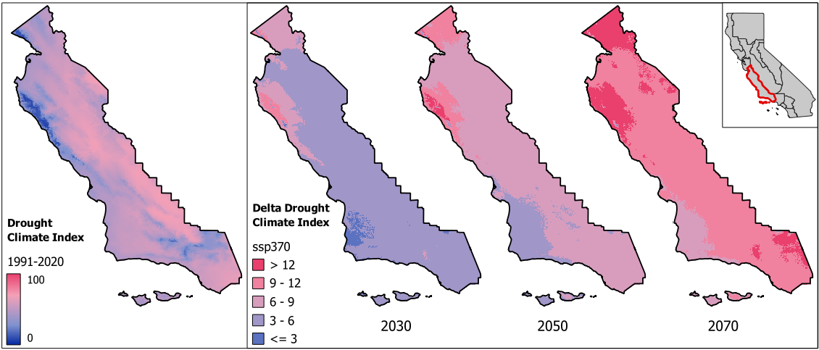

*Source: Risklayer GmbH*

Figure 1b highlights how drought risk evolves across California’s Central Coast region. The left panel illustrates the historic drought climate risk index, based on a 30-year average from 1991 to 2020, using a scale from 0 (low) to 100 (high). These projections show how the index score is expected to shift upward in points on the drought index. Moving rightward, the projections for 2030, 2050 and 2070 under the intermediate emissions scenario, "A Rocky Road" (ssp370), show increasing severity of drought conditions. Notably, Monterey County emerges as a hotspot (darker pink) for worsening drought risk over time, as does southern Santa Clara County.

This drought climate index synthesizes data on precipitation, temperature and moisture availability to capture how drought conditions are expected to change under future climate scenarios. It serves as a critical tool for understanding regional vulnerabilities and helps decision-makers prioritize actions to reduce water scarcity risks and bolster drought resilience in vulnerable areas. The visualization underscores the need for adaptive strategies in the face of intensifying droughts.

***Figure 1c. Earthquake Risk***

Figure 1c depicts average annual losses (AAL) from earthquakes for tourism assets for the Central Coast region. The darker pink areas on the map represent census tracts with higher proportions of probable annual losses relative to the total value of tourism assets, such as hotels, restaurants and other businesses tied to tourism.

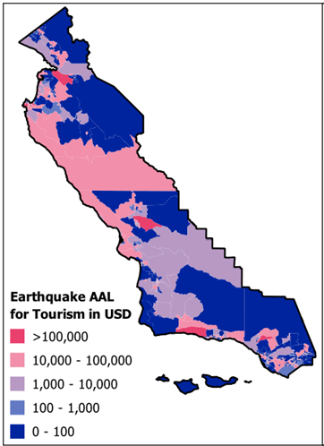

*Source: Risklayer GmbH*

The high AAL in this region is attributed to infrequent but severe earthquakes, which significantly influence the annualized risk. Dark pink pockets near Gilroy and Hollister, Paso Robles, Santa Barbara and Ojai stand out as having heightened earthquake risks.

Landslides also cause damages and disruptions to the transportation network in the Central Coast region, as evidenced by the prolonged closure of Highway 1 at Regent’s Slide near Big Sur.

Other risks included in the CSF 1 analysis are the safety and security index, which considers factors,such as COVID-19 vaccination rates, overall safety, personal security index, average annual healthcare spending, family friendliness, women's well-being and homelessness.

A key component, the homelessness intensity index, is a weighted metric based on emergency shelters, rapid rehousing and permanent supportive housing — with emergency shelters weighted most heavily due to their acute impact. Most counties in the Central Coast region score below the state average, indicating a relatively lower homelessness burden. However, Santa Clara County stands out with a significantly higher index value, reflecting the elevated homelessness challenges in its dense urban centers.

Emergency and homeless shelter resources are unevenly distributed across the region. While some areas, particularly in more urbanized parts of San Luis Obispo and Santa Barbara counties, have multiple facilities with varying capacities, rural and isolated communities often lack adequate infrastructure. This gap creates disparities in local access to emergency housing and weakens regional resilience during times of crisis.

Seasonal fluctuations, especially in winter, further strain the availability of shelter. The limited number of beds relative to the region’s population indicates a potential shortfall in temporary housing during widespread evacuation or disaster scenarios. Beyond emergency response, this issue also impacts community well-being and equity, as discussed in CSF 6. These localized disparities highlight the need for more targeted interventions, even in regions that perform well overall.

The assessment of economic risks in the Central Coast region encompassed several key factors: economic stability, workforce availability (as measured by unemployment rate), housing affordability and housing displacement risk. Across the entire region, the quantitative rating of housing affordability is notably low, with values ranging from 50 to 60. This rating reflects the difficulty a typical household faces in purchasing an existing home in the area. The low housing affordability scores support the earlier observation about Santa Clara County's high homelessness rating. The low housing affordability rate throughout the region likely exacerbates homelessness.

All of these risks will be visualized on the web-based [California Tourism Resilience & Sustainability Dashboard](https://www.risklayer-explorer.com/region/title=California/overview), providing a comprehensive view of the vulnerabilities and strengths of the Central Coast region.

### CSF 1 qualitative ratings and findings

Qualitatively, the panelists were asked to assess the region across the following performance criteria:

#### Risk perception

Gauges the panelists’ awareness of 11 types of risks affecting tourism, including natural disasters, climate change, water scarcity, air quality, economic factors, public health concerns and technological disruptions.

#### Understanding tourism impacts

Considers panelists’ perceptions of the extent to which tourism stakeholders understand the impacts of natural disasters, climate change, environmental and ecological issues, public health crises, social, technological, political issues and economic uncertainty.

#### Risk Information Sharing

Analyzes panelists’ perceptions of the degree to which risk-related information (e.g., data, maps, studies) on tourism assets and destinations is communicated effectively to tourism stakeholders and policymakers to support informed decision-making.

#### Data sharing effectiveness

Examines panelists’ perceptions of the effectiveness of existing mechanisms for sharing risk data with tourism stakeholders and policymakers to inform them about key risks and prevention strategies.

The panelists evaluated the individual performance criteria for CSF 1 and assigned a score of 2 out of 5 at a relatively consistent level. This score reflects two key observations:

First, tourism stakeholders have a basic understanding of the importance of proactively mitigating risks. However, this understanding appears to be limited, suggesting room for improvement in risk awareness and management.

Second, the practice of sharing data between tourism entities and emergency planning organizations is inconsistent. The panelists note that while some data sharing occurs, it is infrequent and still in its early stages. This indicates a need for more robust and regular information exchange between these sectors to enhance overall risk preparedness and response.

The four individual performance criteria and the subsequent findings are shown in Table 1 below:

***Table 1. CSF 1 qualitative performance criteria ratings***

|  |  |  |
| --- | --- | --- |
| ***Performance criteria*** | ***Rating*** | ***Findings*** |
| **Risk perception** | 2.1 | Natural disasters are perceived as the highest risk in the region, followed closely by economic risks like inflation and downturns. Climate change, water scarcity, air quality, environmental impacts, public health and societal concerns are rated as moderate risks. Geopolitical issues and safety concerns (crime and homelessness) are seen as low risks. Technological disruptions are perceived as the lowest risk. |
| **Understanding tourism impacts** | 2.2 | Tourism stakeholders in the region demonstrate varying levels of understanding across different risk categories. They have a moderate grasp of how natural disasters and public health crises impact the tourism sector. However, their comprehension of economic uncertainty's effects is more limited. When it comes to climate change, environmental and ecological issues, social factors, technological changes and political risks, stakeholders' understanding is limited. This uneven awareness suggests a need for more awareness of data on the full spectrum of risks affecting the tourism industry. |
| **Risk information sharing** | 2 | Most panelists indicate that the current state of risk information access for tourism assets and destinations is characterized by inconsistent access, a basic repository and fragmented communication. They also highlight significant challenges in effectively addressing these risks. |
| **Data sharing effectiveness** | 2 | Most panelists indicate that the current mechanisms for sharing risk data are only somewhat effective, needing improvement. Only some stakeholders are informed about key risks and prevention strategies, highlighting a need for enhanced data-sharing systems. |

“In the last 10 years the region has experienced major flooding, landslides, wildfires, earthquakes during hurricanes; all of which were heavily played in the media making awareness very visible. Information on these risks is available, but only when there is an emergency is it translated to tourism messaging.”

“Policymakers aren't aware of the universe of data available that statewide organizations have. If these tools were universally available, I believe it would improve decision making and the public engagement process.”

# CSF 2 — Managing Resilience

This CSF reviews existing local plans and strategies that have been adopted to mitigate adverse impacts from and adapt to climate change-related disasters, as well as manage risk from other natural disasters.

### CSF 2 key findings

CSF 2 outcomes on managing destination resilience reveal that some cities and counties in the region have adopted disaster risk and climate plans — including the Santa Barbara 2030 Climate Action Plan — but there remains significant room for improvement. These results are based on quantitative analysis of city and county-level planning data, which reflect public sector efforts to address climate-related hazards. The highest score is for disaster risk management plans (52 out of 100), indicating that many jurisdictions have taken steps to prepare for potential disasters. Climate mitigation plans scored slightly lower at 45 out of 100, suggesting uneven progress in reducing emissions and other drivers of climate change. The lowest score, 38 out of 100 for climate adaptation, highlights a gap in comprehensive strategies to adjust to long-term climate impacts.

In contrast, qualitative input from tourism stakeholders reveals that these public sector efforts have not yet translated into meaningful engagement with or relevance to the tourism industry. Panelists report a lack of consistent coordination between tourism entities and the local authorities responsible for climate and disaster planning, with most collaboration occurring on a limited or ad hoc basis.

There are, however, promising examples of tourism-led resilience planning — such as the [Big Sur Destination Stewardship Plan](https://www.cabigsur.org/wp-content/uploads/2020/11/Big-Sur-Destination-Stewardship-Plan-Final-0720.pdf) or San Luis Obispo’s Experience [SLO CAL 2050 Destination Management Strategy](https://assets.simpleviewinc.com/simpleview/image/upload/v1/clients/slocal/Final_DMS_4d2a2f36-5ded-4216-acaa-30b7b2f44d0d.pdf) — which can serve as examples for other destinations across the region and state.

Tourism stakeholder feedback varied across qualitative performance criteria, reflecting uneven levels of awareness and preparedness within sub-regions. While some places are recognized for integrating climate and resilience goals into destination planning, panelists consistently emphasized that the tourism sector has yet to meaningfully incorporate these issues into long-term strategy. This does not imply that individual businesses or DMOs are inactive — rather, it underscores the need for broader regional coordination to ensure the tourism industry is better aligned with climate preparedness and hazard response.

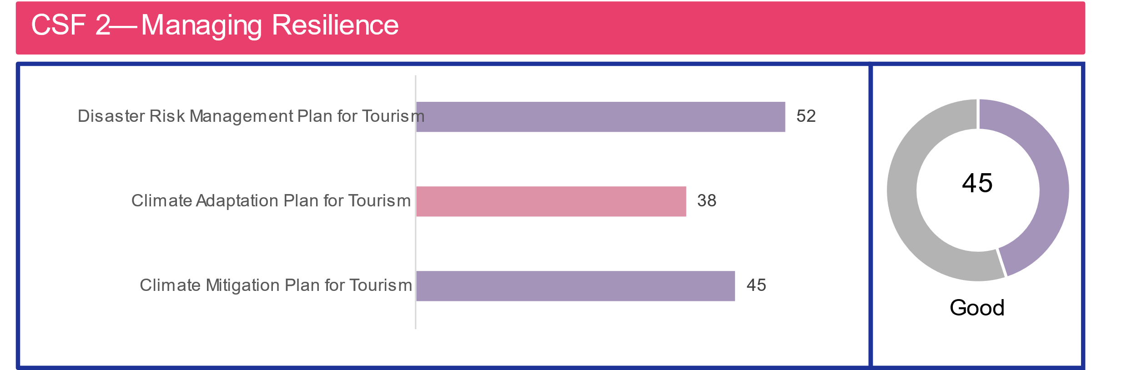

### CSF 2 quantitative rating descriptions

An inventory of local destinations was compiled, and a desk top review was completed to evaluate each plan along three criteria:

#### Disaster risk management planning

#### Indicates whether a destination has identified and mapped specific hazards, conducted detailed risk assessments, analyzed vulnerabilities, and developed robust disaster management plans and hazard mitigation strategies. The presence and comprehensiveness of these plans and strategies indirectly reflect the destination's capability to safeguard visitors, local communities, and tourism infrastructure from potential impacts of natural or man-made disasters.

#### Climate adaption planning

Indicates whether a destination has developed a plan that discusses improving resilience of infrastructure to climate-change related disasters, consideration of water resource management, mitigation measures for floods and sea-level rise and public policies to integrate climate change considerations into broader planning framework. These plans typically include measures to reduce vulnerability to climate-related risks and capitalize on potential opportunities arising from changing climate conditions.

#### Climate mitigation planning

Refers to the existence of a plan focused on reducing greenhouse gas emissions from local economic activity the community’s contribution to climate change. Such plans usually include strategies to decrease greenhouse gas emissions from the built environment, promote sustainable practices and support the transition to low-carbon business operations, including in the tourism sector.

*CSF 2 qualitative ratings and findings*

Qualitatively, the panelists assessed the region on CSF 2 across the following performance criteria:

#### Budget allocation and regulation

Indicates panelists’ perceptions of whether policies and regulations are in place to mandate or support tourism stakeholders in advancing resilience investments through planning and compliance mechanisms, along with appropriate government budget allocations to fund these requirements.

#### Risk-based tourism planning

Indicates the extent to which panelists feel disaster- and climate-related risks are incorporated into tourism-related economic development plans and local zoning regulations to minimize vulnerabilities and support safe, sustainable tourism practices.

#### Collaboration and coordination

Assesses panelists’ perceptions of the extent to which the tourism sector actively collaborates with public authorities responsible for disaster risk management and climate change adaptation in the region.

#### Effectiveness of resilience measures

Evaluates panelists’ perceptions of the effectiveness of implemented measures, such as infrastructure design, disaster risk financing and coordination agreements, in reducing the impacts of natural disasters.

#### Climate action

Measures panelists’ perceptions of the integration of climate change adaptation into tourism planning and evaluates the industry's active adoption of measures addressing ongoing climate impacts on the tourism sector.

The five individual performance criteria and the subsequent findings are shown in Table 2 below:

***Table 2. CSF 2 qualitative performance criteria ratings***

|  |  |  |
| --- | --- | --- |
| **Performance criteria** | **Rating** | **Findings** |
| **Budget allocation and regulation** | 2 | While most panelists agree that policies exist and are promoted, their perceived effectiveness varies widely. Regarding budget allocations for resilience initiatives, the consensus leans towards inadequacy. Most panelists characterize the funding as very limited and insufficient to tackle resilience challenges effectively. |
| **Risk-based tourism planning** | 2 | The average score indicates that specific aspects of development plans and zoning regulations partially incorporate risks related to tourism, including disasters and climate change impacts. There are differences of opinion among panelists, with some viewing the risk consideration as minimal while others see more substantial integration. |
| **Cooperation and coordination** | 2 | The average score suggests that there is limited interaction and basic coordination between the tourism sector and authorities responsible for disaster risk management and climate change adaptation. Opinions vary, with some panelists perceiving minimal engagement and others recognizing more regular coordination and collaborative efforts. |
| **Effectiveness of resilience measures** | 3 | The average score suggests that resilience measures have moderate impact. Panelists' views range from limited impact to minimal effect, with some noting few or no implemented measures. |
| **Climate action** | 1 | Most panelists report limited awareness and minimal consideration of long-term climate actions in the region's tourism sector. Climate resilience planning is seen as poorly integrated. One panelist notes basic awareness and initial steps, while another observes progressive adaptation and active engagement in parts of the region. |

“Throughout the coast of California, we are losing roads and infrastructure due to sea-level rise and changing weather, but money is not there to plan for different locations or to implement a managed retreat.”

“Often in the face of disasters, people get focused on making the emergency repair and are complacent about looking at the long-term strategy of sustainability.”

## CSF 3 — Preparedness and Response

This CSF focuses on the region's ability to anticipate, respond to and recover from crises or disasters while maintaining competitiveness.

### CSF 3 key findings

The Central Coast region’s overall rating of 26 out of 100 in crisis response capacity indicates significant gaps in emergency readiness. While some local destinations have taken proactive steps in developing emergency preparedness plans, the region continues to face substantial challenges in translating planning into operational capacity.

The emergency preparedness and response plan score of 63 out of 100 is the highest among the metrics, reflecting prior efforts to establish local emergency plans. However, this score stands in stark contrast to the other indicators, highlighting a critical disconnect between planning and execution. Plans may exist, but the infrastructure and resources required to implement them effectively are lacking.

The road accessibility score of 10 out of 100 underscores major issues that could hinder both evacuation and emergency response. This is particularly concerning in areas like Big Sur, where the protracted closure of Highway 1 at Regent’s Slide illustrates the risk of limited ingress and egress in the event of a disaster. Emergency shelter capacity (27 out of 100) is low and emergency healthcare (58 out of 100) is ranked moderately, pointing to the region’s limited ability to house and treat displaced individuals during a crisis.

The infrastructure density index score of 19 out of 100 signals vulnerability in the power distribution system, especially in high fire-risk zones prone to Public Safety Power Shutoffs (PSPS) during periods of dry and windy conditions. These pre-emptive outages, while designed to reduce wildfire risk, often leave communities — residents, visitors, and critical facilities — without power for extended periods. This can disrupt communication systems, strain healthcare delivery, and delay emergency response and recovery efforts. Areas with a high concentration of essential services but limited access to backup power are particularly susceptible to cascading impacts from power outages.

Panelists’ responses reinforce these findings. The tourism sector’s qualitative ratings for public-private partnerships and preparedness/mitigation measures are both moderate (3 out of 5), consistent with the region’s higher score in emergency planning. However, there is a shared understanding that implementation remains uneven and that the broader emergency infrastructure is underdeveloped.

These findings highlight the importance of independent preparedness and contingency planning. In the absence of sufficient public infrastructure, the tourism sector must factor in regional vulnerabilities and explore ways to support both residents and visitors during crises, such as the role of hotels and lodging facilities as temporary shelters if public resources become overwhelmed.

Improved data sharing and communication within the tourism sector and with local government agencies represents a low-cost, high-impact strategy. Disseminating region-specific risk data can enhance both awareness and preparedness, equipping stakeholders with a more complete understanding of regional capacity, infrastructure gaps, and the collective steps needed to strengthen resilience. Strategic investments in coordination and planning — especially in the face of increasingly frequent climate-related disruptions — will be essential to protecting both communities and the tourism economy in the Central Coast.

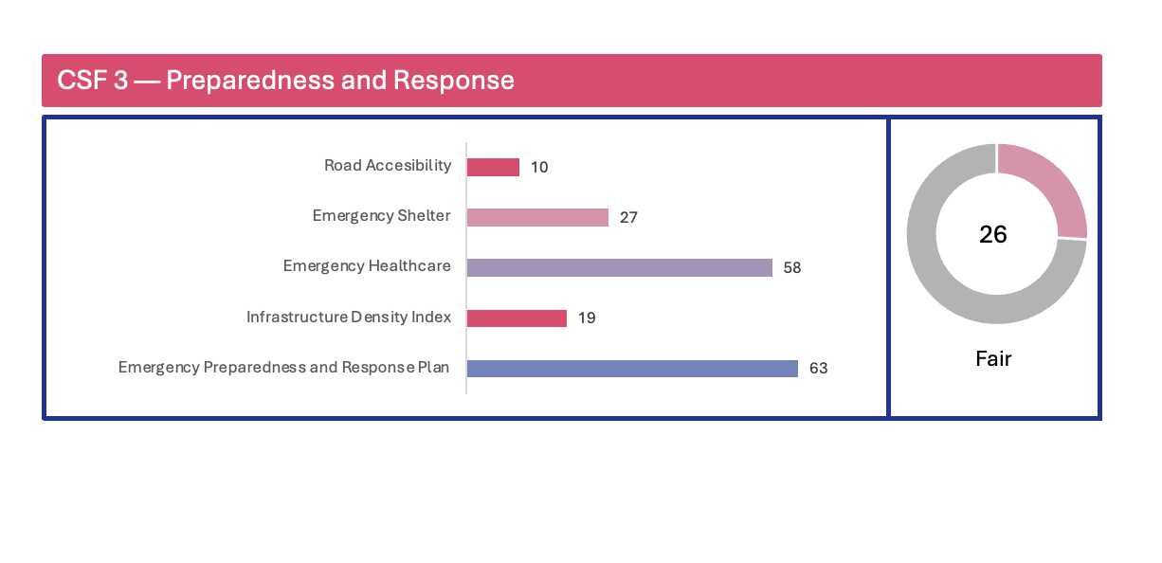

### CSF 3 quantitative rating descriptions

CSF 3 considers key regional infrastructure essential to responding to an emergency or natural disaster, as well as the region’s preparedness to respond to and recover from the priority risks facing the region — heatwaves, drought and earthquakes:

#### Road accessibility

Utilizes Risklayer analysis to assess road accessibility in terms of proximity to airports, road condition and connectivity.

#### Emergency shelter availability

Calculates the number of emergency shelters per 10,000 residents; provides a quantitative measure of shelter accessibility in case of emergencies.

#### Emergency healthcare availability

Measures the number of hospitals per 10,000 residents; indicates the level of emergency medical care accessibility in the region.

#### Infrastructure density index

Evaluates infrastructure density based on the length of electric transmission lines per region, serving as a proxy for urbanization and overall infrastructure development.

#### Emergency preparedness and response planning

Employs a desktop review of emergency preparedness plans such as Emergency Operations Plans (EOPs) of counties or local government and evaluates quality and detail of key components such as clearly defined roles and responsibilities, coordination mechanisms, communication protocols including public warning systems, evacuation and sheltering strategies, resource allocation processes, and established cooperation agreements. Risklayer analysis of emergency preparedness based on accessibility, proximity to emergency facilities and transportation network conditions to provide a comprehensive view of readiness for potential crises.

### CSF 3 qualitative ratings and findings

Qualitatively, the panelists assessed the region’s performance on CSF 3 across the following performance criteria:

#### Disaster preparedness and response

Assesses panelists’ perceptions of the involvement of tourism stakeholders in decision-making during and after disasters to minimize disruptions and losses and, as a result, maintain competitiveness of the tourism destination.

#### Public-private partnerships

Examines panelists’ awareness of agreements and policies that mobilize public and private resources to enhance preparedness of the tourism sector, such as disaster communication, emergency services and shelter management.

#### Preparedness and mitigation

Reviews panelists’ perceptions of the availability of early warning systems, post-disaster shelter plans, contingency plans of key service providers and strategies to mitigate reputational risks through marketing and communication.

#### Response and recovery measures

Evaluates panelists’ perceptions of the effectiveness of recovery tools, such as government stimulus packages, targeted support for vulnerable groups and the advocacy skills of tourism leaders in the region to secure government resources.

The four individual performance criteria and the subsequent findings are shown in Table 3 below:

***Table 3. CSF 3 qualitative performance criteria ratings***

|  |  |  |
| --- | --- | --- |
| **Performance criteria** | **Rating** | **Findings** |
| **Disaster preparedness and response** | 2 | Panelists indicate that tourism stakeholders have limited representation or involvement in disaster response decisions and actions. |
| **Public-private partnerships** | 3 | Most panelists agree some partnerships and policies are in place, but with gaps. Some panelists indicate there are no or limited agreements in parts of the region. |
| **Preparedness and mitigation** | 3 | Most panelists agree that early warning systems, post-disaster shelter plans and contingency plans for critical infrastructure are partially integrated. Some panelists perceive limited recognition of these risks, while others note comprehensive reputation management strategies in certain parts of the region. |
| **Response and recovery measures** | 2.3 | Panelists agree that financial relief for tourism has had a significant impact. They also perceive targeted support for vulnerable groups and advocacy for preparedness and response to be effective. |

“Tourism involvement in decision-making is inconsistent, many times based on relationships with disaster decision makers. There are agreements in place to manage the public in a disaster [and] to that extent it would include tourism, but it is not specifically [developed] with that industry in mind.”

## CSF 4 — Investing in Sustainability

This CSF involves integrating resilience and sustainability into tourism planning and operations through investment, risk management, diversification and resource allocation.

### CSF 4 key findings

The CSF 4 outcome shows the Central Coast region has low greenhouse gas emissions, notable challenges in economic output and has received limited public investment in tourism-specific climate initiatives. The composite score is 44 out of 100, reflecting a region with strong environmental performance but uneven progress in broader resilience and sustainability investment.

The region performs exceptionally well on greenhouse gas emissions per capita (83 out of 100), driven by factors such as lower population density and relatively limited GHG-intensive economic sectors. This strong performance also helps explain why the region has not been a major recipient of California Climate Initiative (CCI) funding, which prioritizes areas with higher emissions. Lower scores across the CCI-related funding metrics are therefore not an indication of underperformance but rather reflect the region’s already low-\ emissions profile.

In contrast, economic performance remains a challenge. The GDP per capita rating (33 out of 100) is low. Annual job growth (49 out of 100) is moderate, but the total number of sustainable hotels (18 out of 100) remains low.

Qualitative responses from panelists reinforce the need for greater investment in tourism-specific resilience and sustainability initiatives. While public-sector infrastructure and tourism projects show some evidence of risk-informed planning, such as incorporating multi-hazard assessments, these practices are not consistent or comprehensive. Investments in protecting tourism assets and businesses are seen as moderate and targeted, rather than strategic or region wide.

A significant concern raised by panelists is the absence of risk transfer strategies, such as insurance, emergency reserves or climate bonds. This receives the lowest possible qualitative score and suggests that tourism assets may be unprotected in the event of disasters or economic shocks, either due to a lack of such mechanisms or a lack of awareness of them.

Transportation infrastructure in the Central Coast continues to favor personal vehicles, which limits mobility options for both residents and visitors. Enhancing public transportation would support more sustainable travel behavior and improve access to under-visited areas.

Together, these findings point to a clear opportunity for a more balanced and comprehensive approach to sustainability in the tourism sector. The Central Coast region would benefit from increased attention to risk transfer strategies and scaling sustainable practices, particularly in the accommodation sector. While the region leads on GHG emissions, translating that success into a broader sustainability and resilience framework will be essential to support tourism’s long-term contribution to community and environmental well-being.

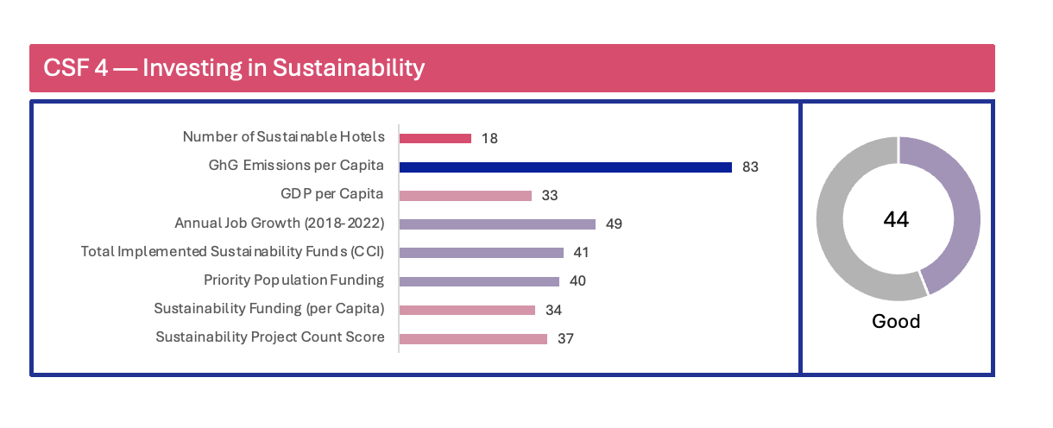

### CSF 4 quantitative rating descriptions

CSF 4 evaluates the region across a myriad of criteria, characterizing investment in and funding for sustainability, as well as the region’s overall economic health:

#### Number of sustainable hotels

Reviews a comprehensive list of sustainable hotels based on [Tripadvisor’s criteria on eco-friendly practices](https://www.tripadvisor.com/GreenLeaders), from linen and towel re-use, recycling and composting to solar panels, electric car charging stations and green roofing. This is the total number of sustainable hotels in the region, not the percentage of all sustainable hotels in the region.

#### GHG emissions per capita

Analyzes GHG emission estimates based on state, regional or federal data sources and aggregated facility-specific emission reports from CARB's [Mandatory GHG Reporting Program](https://ww2.arb.ca.gov/our-work/programs/mandatory-greenhouse-gas-emissions-reporting).

#### GDP per capita

Calculates the region's economic output per person by dividing total Gross Domestic Product (GDP) by total population, serving as an indicator of the area's standard of living and the economic well-being of the local population.

#### Annual job growth (2018-2022)

Measures the year-over-year increase in the number of employed individuals within the region and expresses this growth as a percentage, indicating the rate of job creation in the economy over a 12-month period. The metric incorporates the percent change in total employees between 2018 and 2022 for the scorecard and interprets positive percentages as an increase in employees and negative percentages as a decrease.

#### Total sustainability funds (CCI)

Reviews funding from the [California Climate Initiative (CCI)](https://www.caclimateinvestments.ca.gov/), derived from the state's greenhouse gas (GHG) emissions cap-and-trade auction proceeds, aiming to reduce GHG emissions, strengthen the economy and improve public health and the environment; provides data at the county level.

#### Priority population funding

Reviews funding from the [California Climate Initiative (CCI)](https://www.caclimateinvestments.ca.gov/) for projects benefiting “[priority population](https://www.caclimateinvestments.ca.gov/priority-populations)” households as defined in state statute as disadvantaged communities, low-income communities and low-income households.

#### Sustainability funding (per Capita)

Reviews funding from the [California Climate Initiative (CCI)](https://www.caclimateinvestments.ca.gov/) per resident in each county.

#### Sustainability project count score

Examines the number of [California Climate Initiative (CCI)](https://www.caclimateinvestments.ca.gov/) projects per county and indicates the level of effort invested in climate initiatives within each county and reflects the diversity of project types implemented across different counties.

### CSF 4 qualitative ratings and findings

Qualitatively, the panelists assessed the region’s performance on CSF 4 across the following criteria:

#### Risk-Informed public investments

Reviews the extent to which panelists feel public sector infrastructure projects consider multi-hazard vulnerability/risk studies to tourism.

#### Resilience initiatives and tourism assets

Assesses panelists' perceptions regarding public investment in programs that protect tourism assets, natural attractions and infrastructure and evaluates whether panelists believe such investments are being made and to what extent.

#### Prioritization of tourism product diversification

Evaluates panelists’ perceptions of destination investment aimed at broadening the variety of tourism offerings and assesses efforts to diversify tourism products and experiences.

#### Risk transfer strategies

Measures panelists’ perceptions of the level of risk transfer strategies implemented to safeguard tourism assets against unforeseen risks and includes strategies such as insurance, reserves and climate bonds.

#### Transportation infrastructure

Analyzes panelists’ perceptions of visitor reliance on personal vehicles versus public transportation and assesses the extent to which visitors use green transportation options.

#### Sustainability standards

Examines panelists’ perceptions of the level of support provided to local tourism-related businesses for meeting sustainability requirements.

#### Sustainability funding

Investigates panelists’ perceptions of the availability of funding for resilience and sustainability initiatives in tourism, considering both non-tourism funds and tourism-generated revenue (e.g., taxes and surcharges) to assess support for initiatives such as protecting attractions, promoting eco-friendly practices and enhancing crisis response procedures.

The individual performance criteria and the subsequent findings are shown in Table 4 below:

***Table 4. CSF 4 Qualitative performance criteria ratings***

|  |  |  |
| --- | --- | --- |
| **Performance criteria** | **Rating** | **Findings** |
| **Risk-Informed public investments** | 3 | Regarding public-sector investments in infrastructure and tourism projects, panelists report some consideration is given to projects being risk-informed, with some projects incorporating multi-hazard vulnerability/risk studies. |
| **Resilience initiatives and tourism assets** | 3 | Panelists feel some level of investment (i.e., programs and resources) has gone to resilience initiatives to protect tourism assets, businesses and infrastructure. |
| **Prioritization of tourism product diversification** | 3 | Panelists generally agree there is partial prioritization, and some efforts are being made to diversify tourism products, experiences and interpretation. |
| **Risk transfer strategies** | 1 | Panelists concur that the region has little to no risk transfer measures (e.g., insurance, reserves, climate bonds) applied to assets. |
| **Transportation infrastructure** | 2.5 | Regarding the regionwide visitor journey, panelists feel it is significantly dependent on personal vehicular travel, such as owned or rented cars, versus public transportation. Although clean transportation options are available in some locations, they are generally not utilized by visitors. |
| **Sustainability standards** | 2 | Panelists generally agree that local tourism-related businesses receive limited support with minimal resources tied to meeting sustainability standards. |
| **Sustainability funding** | 2 | Panelists note the allocation of public funds for tourism-related resilience and sustainability initiatives is notably limited. |

"Backlog of infrastructure maintenance makes prioritizing new projects or green infrastructure unpopular with residents and policy makers."

"Much of the tourism experience on the Central Coast is focused on the independence and visual experience of driving a vehicle on area roadways."

# CSF 5 — Managing Growth

This CSF evaluates how tourism strategies address seasonality, visitor distribution, responsible travel, visitor flow monitoring and marketing practices.

### CSF 5 key findings

The Central Coast region performs well across various indicators of sustainable tourism growth, achieving a composite rating of 69 out of 100, one of the highest among California regions. The region demonstrates strength in managing visitor distribution, monitoring tourism impacts and offering a diverse range of attractions, all of which contribute to a well-balanced tourism economy.

Key quantitative highlights include excellent performance in attractions per overnight visitor (88 out of 100) and tourism pressure management (88 out of 100). Traffic congestion (80 out of 100) is also notably well managed, which not only increase visitor satisfaction but contributes positively to overall crisis response capacity by supporting mobility during peak periods or emergencies.

The region performs well in the share of attractions rated 3 stars or higher (78 out of 100), suggesting a high standard of experiences offered. More moderate scores in hospitality employment (50 out of 100), seasonality (49 out of 100) and tourism infrastructure utilization (49 out of 100) point to opportunities for growth in bolstering the tourism workforce, promoting year-round tourism and improving the use of existing tourism assets.

Qualitative input from panelists aligns closely with these quantitative results. Ratings for most performance criteria fall between 3 and 4 out of 5, reflecting a consistent perception that the region is managing tourism growth responsibly. Panelists note that monthly and daily visitor variations are closely monitored, allowing for data-driven decision-making that supports effective tourism pressure management and visitor flow throughout the region.

Efforts to address seasonality are highlighted as particularly impactful. Panelists concur that the region enjoys success in managing seasonal swings and in increasing visitor volume to less-visited areas. These efforts help distribute tourism benefits across the region and reduce strain on high-traffic locations.

Panelists also praise the region’s approach to responsible marketing, noting that strategies are appropriately focused on visitor carrying capacity, seasonality, environmental impact and residents’ well-being. This intentional and balanced messaging supports a sustainable tourism model that accounts for the needs of both visitors and local communities.

Overall, the Central Coast stands out as a leading region in sustainable tourism management. By continuing to focus on diversifying the tourism economy, improving infrastructure use, and enhancing year-round employment, the region can build on its strong foundation to further align tourism with long-term regional well-being and resilience.

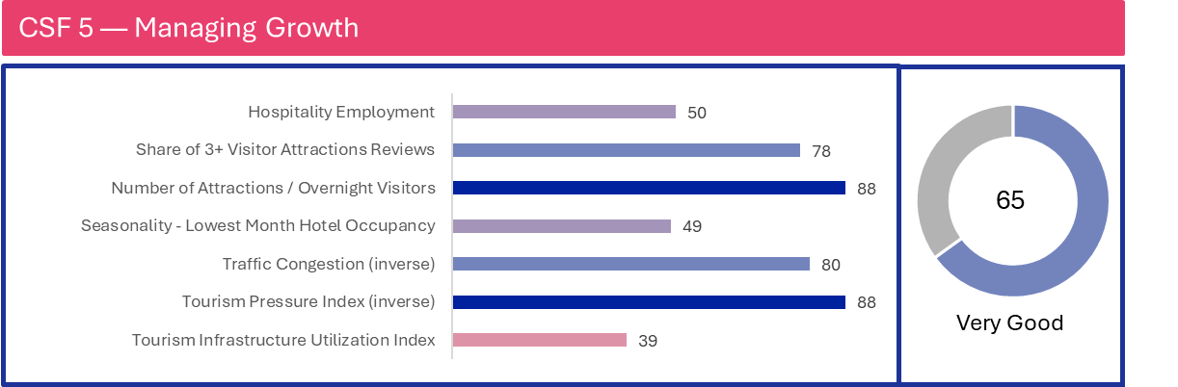

### CSF 5 quantitative rating descriptions

CSF 5 explores the region’s tourism economy and potential for sustainable growth in the industry:

#### Hospitality employment

Measures the total number of people employed in jobs related to accommodations, food service and other visitor-serving industries in the region.

#### 3-star or higher attractions

Calculates the percentage of visitor attractions that have received three stars or higher reviews on [TripAdvisor](https://www.tripadvisor.com/) out of the total attractions in the region.

#### Attractions to overnight visitor ratio

Computes the ratio of total tourist attractions to the number of overnight visitors, indicating the variety of experiences available per visitor.

#### Seasonality

Analyzes the occupancy rate of hotels during the least busy month within a given year, reflecting the destination's seasonality and ability to attract visitors year-round.

#### Traffic congestion (inverse)

Estimates 'peak hour' traffic at all points on the state highway system in the region, showing how near to capacity the highway is operating. Peak hour values represent the total traffic volume in both directions during the busiest typical hour. While a small number of hours each year may have higher traffic volumes, the peak hour represents a more consistent high-traffic period. In urban and suburban areas, this peak hour typically occurs daily on weekdays, with approximately 200 hours per year showing similar traffic levels.

For roads with significant seasonal traffic variations, the peak hour is determined differently. It is identified as one of the four busiest hours of the year but excludes the 30 to 50 hours with the most extreme traffic levels. This approach ensures that the peak hour reflects a traffic volume that occurs frequently during the busy season, rather than including atypical spikes that do not represent regular conditions.

#### Tourism pressure index (inverse)

Measures the ratio of overnight hotel stays to the local population and the density of overnight stays per square kilometer. Each factor is normalized by dividing by its maximum observed value, typically found in highly urbanized areas. The population share component reflects the impact of tourism on the local community, while the stays per square kilometer component indicates tourism intensity and infrastructure density.

By averaging these two normalized ratios, the tourism pressure index provides a balanced measure of tourism's impact on both the local population and the physical environment. This approach allows for comparison across different regions, accounting for variations in population density and urbanization levels. Higher index values indicate greater tourism pressure on the destination.

#### Tourism infrastructure utilization index (TIUI)

Combines multiple indicators related to supply and demand of accommodations (e.g. home rental listings as percentage of hotel rooms, home rental occupancy and others), providing a holistic view of how well tourism infrastructure is being considered to evaluate the utilization of tourism-related accommodation infrastructure across the region.

### CSF 5 qualitative ratings and findings

Qualitatively, the panelists assessed the region on CSF 5 across the following performance criteria:

#### Managing seasonality

Assesses a region's success in increasing off-peak tourism and managing peak visitor flow and measures the region's focus on and results in balancing visitor volume throughout the year.

#### Managing visitor distribution

Evaluates the focus on increasing visitation to less-frequented areas and the success of such efforts.

#### Managing responsible travel

Rates the presence and effectiveness of clear suggestions to encourage sustainable visitor behavior.

#### Monitoring visitor variations

Examines the extent and impact of monitoring visitor trends (e.g., daily, seasonal) to inform tourism management.

#### Responsible marketing

Considers how marketing strategies account for capacity, seasonality, environmental impact and residents’ well-being.

The individual performance criteria and the subsequent findings are shown in Table 5 below:

***Table 5. CSF 5 qualitative performance criteria ratings***

|  |  |  |
| --- | --- | --- |
| **Performance criteria** | **Rating** | **Findings** |
| **Managing seasonality** | 3.3 | Panelists believe the region is reasonably focused on mitigating seasonality with relative success. Efforts are being made to manage visitor flow in high-volume areas during peak periods of demand. The emphasis in the region remains on increasing overall visitor volume rather than mitigating seasonal trends. |
| **Managing visitor distribution** | 3 | Panelists agree there has been a good extent of focus on and relative success in increasing visitor volume to less-visited areas in the region. They feel there is acceptable cross-regional collaboration in marketing programs that highlight assets that are underutilized in each destination. |
| **Managing responsible travel** | 4 | Panelists concur suggestions for visitors to travel responsibly and support sustainability are substantial and effective across the region. |
| **Monitoring visitor variations** | 4 | There is strong agreement among the panelists that monthly and daily variations in visitation are monitored throughout the year and have a significant impact on tourism management regionwide. |
| **Responsible marketing** | 3.25 | Panelists grade the marketing strategies across the region (i.e., initiatives and potential outcomes) typically have a good focus on capacity, seasonality and a focus on impact on the natural environment and residents’ well-being. |

"Marked improvement in the last few years of marketing about being a 'good visitor' to the area but there is room for improvement, especially with tour operators of international guests that have yet to fully return."

"Residents resent off-peak tourism as they lose the opportunity to enjoy attractions when they are less crowded. Improving visitor behavior and lessening impact on roadways I believe will improve that relationship between industry and residents."

"Sustainable travel messaging is moderately effective because for like-minded people they are attracted to that vibe; however, if it's not your jam it doesn't appeal."

## CSF 6 — Community Well-being

This CSF evaluates how well tourism supports community needs and promotes sustainable, inclusive development. It emphasizes community feedback, resident access, equity and responsible tourism development.

### CSF 6 key findings

The assessment of community well-being and engagement in the Central Coast region reveals a nuanced picture, with a composite rating of 64 out of 100. While the region demonstrates clear strengths in gender equity and community engagement, disparities in social vulnerability and community resilience remain areas for focused improvement.

The region’s strongest performance is seen in the women in the workforce indicator (71 out of 100), with women representing a significant portion of the tourism workforce.

Community resilience (58 out of 100) is rated moderately overall, though performance varies by county. San Luis Obispo County performs particularly well. In contrast, Monterey County has the lowest capacity in the region to prepare for and recover from natural hazards, highlighting geographic disparities that could be addressed through more tailored local strategies.

The social vulnerability index (54 out of 100) also reflects regional variation. Santa Barbara and Monterey Counties scored relatively well compared to other parts of the region and state, while Santa Cruz County's lower rating indicates risks among vulnerable populations. Panelists emphasized that certain groups — including low-income residents, the elderly, individuals with disabilities, limited-English speakers, and farmworker communities (e.g., in Pajaro) — face disproportionate challenges related to disaster preparedness and recovery.

Panelists highlight the robust community engagement mechanisms, including resident surveys, town halls, and local advisory committees. The tourism workforce is noted to reflect the demographic diversity of the region, contributing to a sense of cross-cultural exchange, community cohesion, and a growing commitment to diversity, equity, inclusion and belonging within the sector.

Despite these strengths, the qualitative feedback points to a lack of a coordinated regional strategy to manage “overtourism,” which remains a concern of local residents in popular coastal destinations. While the perception of “overtourism” is not uniform across the region, there is agreement that a more deliberate approach to balancing access to popular sites between residents and visitors is needed. Enhancing coordination around visitor flow, equitable access and shared public space would support both community quality of life and long-term tourism sustainability.

Overall, the Central Coast demonstrates a meaningful commitment to community engagement and social well-being. Building on these strengths while addressing gaps in resilience, vulnerability and visitor management will be key to ensuring that tourism supports, not strains, the communities at the heart of the region.

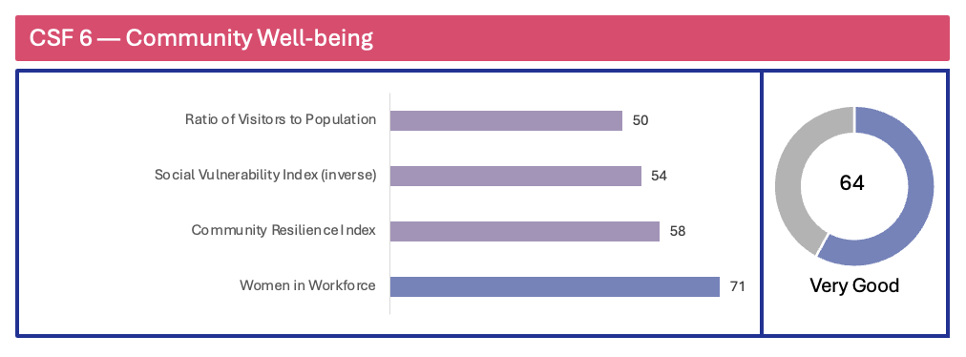

### CSF 6 quantitative rating descriptions

CSF 6 switches the focus to the perspective of the local community and assesses the region through the lens of resident well-being and engagement with the tourism industry. Of the four quantitative metrics, two are derived from the [National Risk Index](https://hazards.fema.gov/nri/) dataset designed and built by the Federal Emergency Management Agency (FEMA). The National Risk Index helps illustrate the U.S. communities most at risk for 18 natural hazards and is measured at the county and census tract levels.

#### Visitor-to-resident ratio

Compares the number of visitors a destination receives to its permanent resident population, indicating the tourism intensity of an area and potential impact of tourism on local infrastructure, services and community.

#### [Social vulnerability index](https://hazards.fema.gov/nri/social-vulnerability) (inverse)

Utilizes 16 socioeconomic variables from the [FEMA National Risk Index](https://www.fema.gov/sites/default/files/documents/fema_national-risk-index_technical-documentation.pdf) to measure a community's reduced ability to prepare for, respond to and recover from hazards and natural disasters.

#### [Community resilience index](https://hazards.fema.gov/nri/community-resilience)

Assesses a community's ability to prepare, plan for, absorb, recover from and adapt to natural hazard impacts using 49 indicators across six resilience types (social, economic, community capital, institutional, infrastructural and environmental) at the county level, as included in the [FEMA National Risk Index](https://www.fema.gov/sites/default/files/documents/fema_national-risk-index_technical-documentation.pdf).

#### Women in workforce

Calculates the proportion of women participating in paid employment compared to the total workforce, serving as an indicator of gender equality in the labor market and reflecting societal norms, economic opportunities and work-life balance policies in a given area.

### CSF 6 qualitative ratings and findings

Qualitatively, the panelists assessed the region’s performance on CSF 6 across the following criteria:

#### Community feedback

Evaluates panelists' perceptions regarding the solicitation of resident feedback about the tourism industry and the frequency with which this feedback influences policies and actions.

#### Community access to sites

Assesses panelists' perceptions of resident access to popular natural and cultural sites, distinguishing local needs from those of tourists.

#### Economic, social and environmental well-being

Analyzes the regional tourism industry's focus on diversity, equity and inclusion in hiring practices, as well as its contributions to cultural heritage preservation, cross-cultural exchange and environmental sustainability.

#### “Overtourism”

Investigates the presence, perception and mitigation of 'overtourism,' including strategies to address future risks associated with excessive visitor numbers.

#### Tourism development

Evaluates the effectiveness of planning guidelines and policies for sustainable tourism development, including the incorporation of resident feedback, management of short-term rentals and preservation of cultural heritage, as perceived by panelists.

The five individual performance criteria and the subsequent findings are shown in Table 6 below:

***Table 6. CSF 6 qualitative performance criteria ratings***

|  |  |  |
| --- | --- | --- |
| **Performance criteria** | **Rating** | **Findings** |
| **Community feedback** | 4 | Panelists agree that resident feedback is thoroughly solicited related to the tourism industry (surveys, town halls and focus groups) throughout the region. |
| **Community access to sites** | 2 | Panelists report there are limited distinctions between residents and tourists with respect to access to highly visited natural and cultural attractions. |
| **Economic, social and environmental well-being** | 3.4 | Panelists believe the diversity of the tourism workforce reflects the residential population. Tourism reasonably contributes to cross-cultural exchange and understanding between tourists and locals. Panelists note the tourism industry is greatly focused on ensuring diversity, equity, inclusion and belonging is a priority in its hiring and retention practices and is taking measures to enhance quality of life for residents while mitigating impacts on the environment. |
| **“Overtourism”** | 2.25 | Panelists report there is minimal to significant visitor capacity issues across the region. Residents perceive moderate “overtourism.” |
| **Tourism development** | 3.25 | Panelists feel planning policies for tourism development exist and are somewhat effective, with resident feedback thoroughly solicited. Measures exist to manage short-term rental inventory and to protect and preserve cultural heritage sites and traditions and are somewhat effective. |

"Actively seeking resident participation into the sustainable tourism discussion is crucial to success."

## 

## CSF 7 — Environmental Conservation

This CSF focuses on promoting sustainable tourism by preserving natural assets, ensuring responsible visitor behavior and addressing environmental impacts.

### CSF 7 key findings

The Central Coast region demonstrates mixed performance across key environmental indicators, with a composite rating of 44 out of 100. While the region shows strong results in biodiversity and air quality, it faces ongoing challenges in land conservation, water management and the environmental oversight of tourism activities.

The region’s strongest performance is seen in terrestrial and aquatic species biodiversity (73 out of 100) and air quality (71 out of 100). These scores are consistent with the region’s lower population density, rural character and low greenhouse gas emissions identified under CSF 4 and point to valuable natural assets that support both conservation goals and visitor experiences. The biodiversity score reflects the ecological richness of the region, making it an important area for continued stewardship.

Water availability (56 out of 100, when inverted) and stream condition (13 out of 100) signal moderate to significant water-related challenges, especially relevant considering California’s recurring and worsening drought conditions and in higher risk areas, such as Carmel and Monterey. Panelists emphasize the need for improved data, monitoring, and enforcement to strengthen overall effectiveness of water conservation practices.

Environmental protection of land and heritage sites presents clear areas for improvement. The conserved areas rating (26 out of 100) shows that a relatively small portion of regional land is under formal conservation, raising concerns for long-term protection of natural landscapes. Similarly, cultural resources (46 out of 100) point to the need for ongoing investment in the preservation of historically significant sites. Panelists note that currently, there is no regionwide inventory of natural heritage or protected areas accessible to tourism stakeholders — a significant gap that impedes coordinated stewardship.

Tourism-related environmental management also shows inconsistencies. Panelists cite strong practices in waste reduction, including the use of reusable products by businesses and attractions, and moderate progress in sustainability awareness. However, systemic issues persist, including the lack of comprehensive guidelines for visitor behavior at natural sites, inadequate tour operator standards and limited oversight of ethical animal tourism practices. The absence of impact assessments on tourism’s contribution to regional emissions further underscores a need for more holistic environmental planning.

The region would benefit from a more integrated environmental management strategy that addresses both immediate concerns (e.g., water availability and visitor behavior) and long-term structural needs (e.g., land conservation and monitoring frameworks). Building on existing strengths in biodiversity, air quality and waste reduction, the Central Coast has a solid foundation from which to advance environmentally sustainable tourism practices that protect its natural assets while enhancing visitor and community well-being.

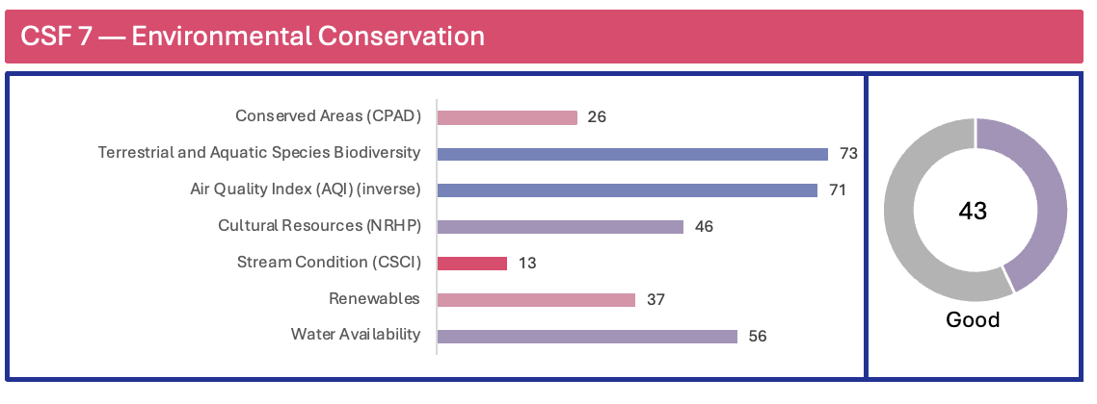

### CSF 7 quantitative rating descriptions

CSF 7 inventories the region’s position with regards to various environmental metrics:

#### Conserved areas

Calculates the percentage of conserved areas within each region using the [California Protected Areas Database](https://calands.org/) (CPAD), which identifies lands owned and protected for open space, including all parks from National Forests to neighborhood pocket parks.

#### Terrestrial and aquatic species biodiversity

Examines native species richness, rare species richness and irreplaceability using the California Department of Fish and Wildlife's [Areas of Conservation Emphasis](https://wildlife.ca.gov/Data/Analysis/ACE) (ACE) dataset. The species biodiversity metric examines three related measures: native species richness, rare species richness and irreplaceability (i.e., areas of high endemism that support a unique species with a limited range). ACE ranks areas from 1 (low species diversity) to 5 (high species diversity). The average species biodiversity metric within the region was calculated to determine relative ratings and rankings.

#### Air Quality Index (AQI) (inverse)

This composite index measures overall air pollution exposure in a given area. It is based on two components: the annual mean concentration of PM2.5 over a three-year period (2015–2017), using data from CalEnvironScreen 4.0 and the California Air Resources Board (CARB); and the 8-hour ozone concentration (in ppm) averaged over three years (2017–2019), also from CalEnvironScreen. Higher index values indicate better air quality. The AQI reflects long-term exposure risks to respiratory and cardiovascular health from both fine particulate matter and ground-level ozone.

#### Cultural resources

Quantifies the number of historic places within the region listed in the [National Register of Historic Places](https://www.nps.gov/subjects/nationalregister/index.htm), as defined by the National Park Service as worthy of preservation.

#### Stream conditions

Evaluates the percentage of streams meeting designated biological uses within the region using the [California Stream Condition Index](https://www.waterboards.ca.gov/water_issues/programs/swamp/bioassessment/docs/csci_factsheet.pdf) (CSCI), a biological rating tool assessing freshwater stream health. This tool is based on an assessment of a wide array of environmental data associated with each stream and sets forth benchmarks for sites based on the local environmental setting. CSCI ratings provide a threshold above which a stream segment is determined to meet designated biological uses. The percentage of those streams that “meet designated biological uses” within the region was calculated to determine relative ratings and rankings.

#### Renewables

Calculates the total percentage of energy generated by renewable resources within the region using utility-scale (>1 MW) power plant generation data from the [California Energy Commission](https://www.energy.ca.gov/data-reports/energy-almanac/california-electricity-data/electric-generation-capacity-and-energy). Large hydroelectric plants (>30 MW) are considered non-renewable. The total percentage of energy generated by renewable resources within the region is calculated to determine relative ratings and rankings.

#### Water availability

Combines precipitation, drought and current/future water stress variables to create a comprehensive measure of water scarcity in the region.

##### Drought

Analyzes five years (2019-2023) of weekly [U.S. Drought Monitor](https://droughtmonitor.unl.edu/CurrentMap/StateDroughtMonitor.aspx?CA) (USDM) data for California monitoring sites, classifying drought conditions from normal to exceptional. The [U.S. Drought Monitor](https://droughtmonitor.unl.edu/CurrentMap/StateDroughtMonitor.aspx?CA) (USDM) is a weekly assessment of drought conditions by multiple federal agencies based on a variety of water-related variables including precipitation, streamflow, reservoir levels, temperature, evaporation potential, vegetation health and more. USDM combines data into six classifications to identify drought conditions from normal (or wet) to exceptional drought.

##### Precipitation

Computes the average 30-year normal precipitation value (1991-2020) within the region using data from the [PRISM Climate Group](https://www.prism.oregonstate.edu/).

##### Current water stress

Identifies and evaluates current global water risks using the [World Resources Institute's (WRI) Aqueduct tools](https://www.wri.org/aqueduct). This metric quantifies current water supply (upstream consumptive water users and large dams on downstream water availability) and demand (domestic, industrial, irrigation and livestock uses) factors through Aqueduct's current water stress data. It places areas into water stress categories ranging from low to extremely high and analyzes current water stress values in each study area to determine relative ratings and rankings.

##### Future water stress

Identifies and evaluates future global water risks using the [World Resources Institute's (WRI) Aqueduct tools](https://www.wri.org/aqueduct) to predict future water supply (upstream consumptive water users and large dams on downstream water availability) and demand (domestic, industrial, irrigation and livestock uses) factors through Aqueduct's future water stress data for 2030. It places areas into water stress categories ranging from low to extremely high and analyzes future water stress predictions for 2030 in each study area to determine relative ratings and rankings.

### CSF 7 qualitative ratings and findings

Qualitatively, the panelists assessed the region’s performance on CSF 7 across the following criteria:

#### Managing protected sites

Evaluates the accessibility, usefulness and effectiveness of maintaining and using a list of natural heritage sites and protected areas, including ongoing conservation processes.

#### Guidelines for behavior at natural sites

Assesses the presence and effectiveness of regionwide guidelines for visitor behavior and tour operators to ensure responsible management of natural sites.

#### Ethical animal tourism

Focuses on guidelines for ethical animal interactions in tourism, ensuring alignment with global standards like the [Global Welfare Guidance for Animals and Tourism](https://www.abta.com/sites/default/files/media/document/uploads/Global%20Welfare%20Guidance%20for%20Animals%20in%20Tourism%202019%20version.pdf).

#### Reusable products

Measures the prioritization of reusable products over single-use items in tourism businesses and attractions.

#### Water usage

Examines the implementation and effectiveness of regionwide water conservation guidelines for tourism-related activities.

#### Emissions information on tourism

Considers how tourism's impact on emissions is measured and integrated into broader environmental goals and policies.

The six individual performance criteria and the subsequent findings are shown in Table 7 below:

***Table 7. CSF 7 qualitative performance criteria ratings***

|  |  |  |
| --- | --- | --- |
| **Performance criteria** | **Rating** | **Findings** |
| **Managing protected sites** | 2.3 | Panelists believe there is an incomplete list of regional natural heritage sites and other protected areas/natural assets that is readily accessible to tourism stakeholders. Additionally, there are few ongoing processes to measure performance and implement steps to protect natural assets in the region. |
| **Guidelines for behavior at natural sites** | 1 | Panelists report that there are no regionwide guidelines in place for appropriate visitor behavior at natural sites or for tour operators and tour guides regarding visitor management at natural sites. |
| **Ethical animal tourism** | 2 | Panelists note that there are few regionwide guidelines for ethical animal tourism, including interaction with wildlife and domesticated animals. |
| **Reusable products** | 4 | Panelists agree that tourism businesses and attractions generally focus on using reusable products. |
| **Water usage** | 3 | Panelists feel there is a reasonable amount of regionwide guidelines in place related to water conservation by tourism businesses and attractions. |
| **Emissions information on tourism** | 2 | Panelists believe tourism's impact on the region's overall emissions goal is narrowly considered and measured. |

"Tourists looking for heritage sites will find them, but they are not well marketed to draw people."

"Properties do a good job of marketing their green status and environmental practices."

"Environmental practices like no straws, recyclable packaging and water conservation are embraced by the community."

## Opportunities for incremental improvement

The Central Coast Scorecard is intended as a baseline resource to raise awareness of current sustainability efforts and the risks to tourism in the region. What emerges as the most critical issue is the region’s lack of essential infrastructure for disaster preparedness and response. This gap includes insufficient emergency shelters, hospitals and other vital systems needed to effectively manage disasters. Without these support structures, the region remains highly vulnerable during crises, with limited capacity for swift response and recovery, posing serious risks to both residents and visitors.

Addressing infrastructure issues primarily resides with local, state and federal governments. However, there are still several opportunities for travel and tourism entities in the Central Coast region to pursue to improve the overall sustainability and resilience of the industry to climate-related and other natural disasters:

### Be prepared.

* Use the [California Tourism Resilience & Sustainability Dashboard](https://www.risklayer-explorer.com/region/title=California/overview) to identify potential impacts to tourism from various hazards and disaster events.
  + Organize webinar training sessions to familiarize tourism stakeholders, local officials and the broader public with the dashboard and how to interpret the data.
  + Determine which communities are most vulnerable to and face the greatest risks from tourism losses from natural disaster and other events.
* Develop scenario-based exercises focusing on the region’s high-priority risks — drought, heatwaves and earthquakes — tailored for small and medium tourism businesses and DMOs, with an emphasis on supporting the most vulnerable communities.
  + Adopt emergency response strategies to prepare for higher risk crisis situations.
  + Provide guidance on effective post-crisis recovery strategies.
* Prepare a regional risk-based action plan focused on protecting tourism assets, including tourism products prioritized for development in the Central Coast Regional Strategic Tourism Plan, from the top risks identified under CSF 1:
  + Provide a detailed risk profile of key tourism assets.
  + Identify steps for mitigating impacts identified in the risk profile.
  + Incorporate mitigation/resilience improvements into operation budgets.
* Establish communication channels between tourism stakeholders, emergency services, regional news media and visitors to support timely and accurate information dissemination during crises:
  + Prepare a list of mobile apps, websites and local radio stations providing real-time updates on weather conditions and disaster alerts.
  + Develop tools, such as regular email updates, a dedicated hotline or social media updates for instant alerts, to communicate risk information to tourism businesses.
  + Pursue partnerships with local government to establish temporary agreements for converting facilities into emergency shelters during crises.

### Act sustainably.

* Pursue sustainability certification through recognized frameworks, such as the Global Sustainable Tourism Council Criteria for hotel and tour operators, destinations, venues, event organizers, events & exhibitions and attractions.
* Incorporate sustainability initiatives into regular operations.
  + Install water-conserving and/or energy-efficient measures that exceed building code requirements when replacing existing building components.
  + Pursue electric utility and local, state and federal government incentives for clean energy improvements and electric vehicle charging infrastructure (see [Statewide Opportunities](https://travelmattersca.com/-/media/travel-matters-site/issue-and-insights/regional-strategic-tourism-plans/plans/travelmatters_visit-california-statewide-plan.pdf) for more information).
  + Partner with local businesses to create a closed-loop system for resources, such as turning food waste into compost for local farms that supply restaurants.
  + Collect relevant data, including guest satisfaction ratings, initial investment costs, ongoing maintenance expense, energy and water savings and waste reduction to determine the long-term financial benefits of sustainable practices.

### Manage responsible visitation.

* Develop a strategy to manage visitation in popular areas to avoid exceeding capacity during peak periods:
  + Gather seasonal visitation data and monitor fluctuations to identify and address shifting demand patterns (monthly and daily) in a timely manner.
  + Partner with public agency stakeholders to collect visitor data at high-trafficked public sites to inform visitor management strategies.
  + Identify sites experiencing environmental degradation from visitation exceeding capacity, assign a level of urgency and develop a strategy for mitigation that includes resources and monitoring performance against KPIs.
* Create guidelines for visitor behavior at natural sites, communicate guidelines at all stages in the visitor journey and create a system to monitor the impact of visitor impact on natural sites.
* Implement campaigns on a regionwide basis, like Leave No Trace and Cleaner California Coast, to educate visitors on the importance of sustainability and how their choices can make a difference.
  + Leverage Visit California’s Responsible Travel Code resources to encourage positive visitor behavior.
  + Emphasize pre-trip engagement, such as the USFS’s [Know Before You Go](https://www.fs.usda.gov/visit/know-you-go), to encourage visitors to plan effectively prior to arrival at a destination.

## Conclusion



This scorecard highlights unique challenges facing the Central Coast region regarding climate change and water scarcity. These pressures underscore the urgency of advancing robust sustainability approaches. Without sufficient progress, the region faces distinct challenges that could impact its tourism industry and overall resilience.

There is energy, enthusiasm and commitment from regional stakeholders to address resilience and sustainability issues, which are important not only for the region but for the entire state of California. The strong local support and recognition of sustainability's importance provide a foundation for addressing these issues. Significant work lies ahead to improve the region's performance and prepare for future environmental challenges, particularly in managing drought conditions and adapting to climate change impacts.

# Appendix

## Appendix 1- Reviewed destination plans

|  |  |
| --- | --- |
| **Destination** | **Plan name** |
| Arroyo Grande | [Arroyo Grande Subbasin Groundwater Sustainability Plan](https://www.slocounty.ca.gov/Departments/Public-Works/Forms-Documents/Projects/Arroyo-Grande-Basin/GSP-Resources/Arroyo-Grande-Subbasin-GSP-Public-Draft.pdf) |
| Atascadero | [City Of Atascadero Final Climate Action Plan](https://www.atascadero.org/index.php?option=com_content&view=article&id=934&Itemid=2201) |
| Atascadero | [Downtown Atascadero Infrastructure Enhancement Plan](https://www.atascadero.org/index.php?option=com_content&view=category&id=88&Itemid=1727) |
| Atascadero | [Scoping Meeting Briefing Book Atascadero 2045 General Plan Update](https://www.atascadero2045.org/files/managed/Document/46/Atascadero%20GPU_Scoping%20Meeting%20Briefing%20Book_FINAL_01-20-2022.pdf) |
| Big Sur | [Big Sur Destination Stewardship Plan](https://www.cabigsur.org/wp-content/uploads/2020/11/Big-Sur-Destination-Stewardship-Plan-Final-0720.pdf) |
| Buellton | [City Of Buellton General Plan Updated](https://www.cityofbuellton.com/files/2025%20General%20Plan/General%20Plan%20Updated%2010-2017.pdf) |
| Camarillo | [2020 Urban Water Management Plan](https://cms7files.revize.com/camarilloca/Departments/Public%20Works/water/Camarillo%202020%20UWMP.pdf) |
| Camarillo | [City Of Camarillo 2021 General Plan](https://www.ci.camarillo.ca.us/departments/community_development/general_plan.php) |
| Camarillo | [Climate Action Plan & Safety Element Update](https://www.ci.camarillo.ca.us/departments/community_development/climate_action_plan___safety_element_update.php) |
| Carmel-By-The-Sea | [City Of Carmel-By-The-Sea Climate Action Plan](https://ci.carmel.ca.us/sites/main/files/file-attachments/climate_adaptation_plan_appendixa_climate_action_plan_prefinal_042822.pdf?1656630014) |
| Carpinteria | [Establishing A Sustainable Community Policy](https://carpinteriaca.gov/wp-content/uploads/2020/03/Sustainable-Community-Policy-Resolution-5500.pdf) |
| Del Rey Oaks | [General Plan Update](https://www.delreyoaks.org/sites/default/files/fileattachments/city_manager/page/1506/1997_generalplanupdate.pdf) |
| El Paso De Robles | [The City Of Paso Robles' General Plan](https://www.prcity.com/313/General-Plan) |
| Fillmore | [Fillmore Basin Groundwater Sustainability Plan](https://s29420.pcdn.co/wp-content/uploads/2021/08/FPBGSA-Fillmore-Basin-GSP-Public-Review-Draft-text-with-figures-no-appendices.pdf) |
| Gilroy | [City Of Gilroy 2040 General Plan](https://www.cityofgilroy.org/DocumentCenter/View/11309/Gilroy-2040-General-Plan-39-MB?bidId=) |
| Gonzales | [Climate Action And Resilience Plan](https://gonzalesla.com/wp-content/uploads/2023/02/gonzalescarp_final.pdf) |
| Greenfield | [Sustainable Greenfield](https://greenfield-ma.gov/departments/energy_and_sustainability/sustainable_greenfield_master_plan.php) |
| Grover Beach | [Climate Action Plan](https://www.grover.org/DocumentCenter/View/4103/Initial-Study---Neg-Dec-Public-Draft-111513?bidId=) |
| Guadalupe | [Guadalupe General Plan Update](https://ci.guadalupe.ca.us/wp-content/uploads/2021/08/Guadalupe-GP-Update_English-Version.pdf) |
| Guadalupe | [Guadalupe Mobility Revitalization Plan](https://ci.guadalupe.ca.us/wp-content/uploads/2020/02/GuadalupeMobilityRevitalizationPlan_FINAL_022120.pdf) |
| Hollister | [Climate Action Plan](https://hollister.ca.gov/wp-content/uploads/2023/04/Hollister_PublicReviewDraft_CAP_2023-03.pdf) |
| King City | [King City General Plan](https://www.kingcity.com/wp-content/uploads/2016/01/City-of-King-General-Plan-with-2007-2014-Housing-Element.pdf) |
| Lompoc | [Streetscape Multimodal Improvement Plan](https://www.cityoflompoc.com/home/showpublisheddocument/37854/638222721604470000) |
| Marina | [Groundwater Sustainability Plan](https://cityofmarina.org/DocumentCenter/View/10750/20200113_City-of-Marina-GSP-VOLUME-I) |
| Monterey | [Climate Action Plan](https://monterey.org/city_hall/community_development/sustainability/city_green_actions/climate_action_plan.php) |
| Monterey County | [Monterey County Sustainability Program](https://www.co.monterey.ca.us/home/showpublisheddocument/105644/637690464706500000) |
| Monterey County | [Monterey County Tourism 2030 Roadmap](https://issuu.com/visitmontereycounty/docs/montereycountytourism_web) |
| Moorpark | [The Moorpark General Plan Update 2050 Program Environmental Impact Report](https://moorparkca.gov/DocumentCenter/View/14998/Final-Environmental-Impact-Report-for-General-Plan-2050?bidId=) |
| Morro Bay | [Downtown Waterfront Strategic Plan](https://www.morrobayca.gov/DocumentCenter/View/11592/City-Council-Adopted-DWSP-2018) |
| Oceano | [The Oceano Dunes Stewardship Study](https://static1.squarespace.com/static/5c53853cb7c92c444615e71a/t/647e000eeb3fe020af9b1266/1685979154610/OD_Oceano+Dunes+Stewardship+Study_+Report_FINAL-compressed.pdf) |
| Ojai | [City Of Ojai General Plan](https://ojai.ca.gov/244/Ojais-General-Plan) |
| Oxnard | [2023 General Plan](https://www.oxnard.org/city-department/community-development/planning/2030-general-plan/) |
| Oxnard | [Climate Action And Adaptation Plan](https://www.oxnard.org/climate-action-plan/) |
| Pacific Grove | [City Of Pacific Grove Climate Change Vulnerability Assessment](https://cms9files.revize.com/pacificgrove/Document_Center/Departments/Community%20Development/Programs%20&%20Projects/Local%20Coastal%20Program/Background%20Documents/pg-lcp-final-vulnerability-assessment-011515.pdf) |
| Pismo Beach | [City Of Pismo Beach Climate Action Plan 2014](http://www.pismobeach.org/DocumentCenter/View/43549/Climate-Action-Plan-Approved-May-2014?bidId=) |
| Port Hueneme | [2020 Strategic Plan](https://www.portofhueneme.org/wp-content/uploads/2015/06/Port_of_Hueneme_2020_Strategic_Plan_SupportingDocuments.pdf) |
| Salinas | [Environmental Impact Report And Climate Action Plan For Comprehensive General Plan Update](https://www.cityofsalinas.org/media-folders/media-root/departments-files/community-development-files/environmental-report-and-climate-action-plan-general-plan-update-rfp-jan-15-2021pdf) |
| Salinas | [The Salinas Plan](https://www.cityofsalinas.org/our-city-services/city-manager/salinas-plan) |
| San Juan Bautista | [San Juan Bautista 2035 General Plan](https://cms6.revize.com/revize/sanjuanbautistaca/document_center/San%20Juan%20Bautista%202035%20General%20Plan/San-Juan-Bautista-2035-General-Plan-FINAL-2-3-16.pdf) |
| San Juan Bautista | [San Juan Bautista Active Transportation Plan](https://cms6.revize.com/revize/sanjuanbautistaca/document_center/San%20Juan%20Bautista%202035%20General%20Plan/San-Juan-Bautista-2035-General-Plan-FINAL-2-3-16.pdf) |
| San Luis Obispo | [Climate Action Plan](https://www.slocity.org/government/department-directory/city-administration/office-of-sustainability-and-natural-resources/climate-action/climate-action-plan) |
| San Luis Obispo | [Experience SLO CAL 2050 Destination Management Strategy](https://assets.simpleviewinc.com/simpleview/image/upload/v1/clients/slocal/Final_DMS_4d2a2f36-5ded-4216-acaa-30b7b2f44d0d.pdf) |
| Sand City | [Sand City Sustainable Transportation Plan](https://files.ceqanet.opr.ca.gov/273895-1/attachment/dYlwVOaCR-aX2TKcGna8FIbiyOmM3T-09e07uK_9rjwe2ruZZLCRQrFq2m7f5QvBNrXje9mJgZhKu1750) |
| Santa Barbara | [2030 Climate Action Plan](https://www.countyofsb.org/1217/2030-Climate-Action-Plan) |
| Santa Barbara | [City Of Santa Barbara Sea-Level Rise Adaptation Plan](https://santabarbaraca.gov/sites/default/files/documents/Services/SLR%20Adaptation%20Plan/Sea-Level%20Rise%20Executive%20Summary.pdf) |
| Santa Barbara | [Sustainability Action Plan](https://content.civicplus.com/api/assets/655aa841-212f-4e39-baeb-db6485dfd466) |
| Santa Maria | [City Of Santa Maria Comprehensive General Plan Update Santa Maria 2040](https://www.cityofsantamaria.org/city-government/departments/community-development/general-plan-update-2040) |
| Santa Paula | [Santa Paula 2040 General Plan](https://www.spcity.org/213/Long-Range-Planning-Special-Studies) |
| Santa Paula | [Santa Paula Two-Year Strategic Plan](http://www.spcity.org/DocumentCenter/View/2124/Santa_Paula_Strategic_Plan_7_21_2021?bidId=) |
| Seaside | [Seaside 2040 General Plan](https://seaside2040.com/index.php/plan-documents/) |
| Simi Valley | [Climate Action Plan](https://www.simivalley.org/home/showpublisheddocument/6906/637001687303600000) |
| Soledad | [General Plan](https://www.cityofsoledad.com/general-plan/) |
| Solvang | [City Of Solvang General Plan Update And Rezoning](https://content.civicplus.com/api/assets/01c5b2c6-8855-48e5-aead-fb5c1f45ac75) |
| Thousand Oaks | [Climate And Environmental Action Plan](https://www.toaks.org/departments/public-works/sustainability/climate-action-planning) |
| Ventura | [Energy Action Plan](https://s29552.pcdn.co/wp-content/uploads/2021-City-of-Ventura-Energy-Action-Plan_March.pdf) |

1. FEMA’s Hazus National Building Inventory, compiles property valuations based on business classification codes (NAICS), census data and commercial building datasets. These datasets help estimate replacement costs, exposure values and potential losses in disaster scenarios. A full listing of assets within these categories can be accessed through FEMA’s publicly available Hazus data. Users interested in exploring detailed records can download and review the datasets at FEMA’s Hazus Data & Resources.